1. Get the project from Git to Local .
2. Configure MAVEN as pom.xml contains all the dependency jar.
3. Import Maven project to IDE.

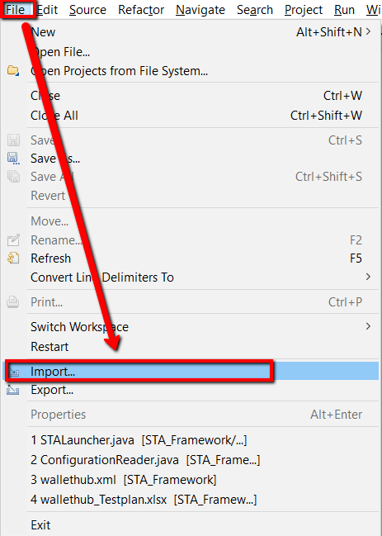

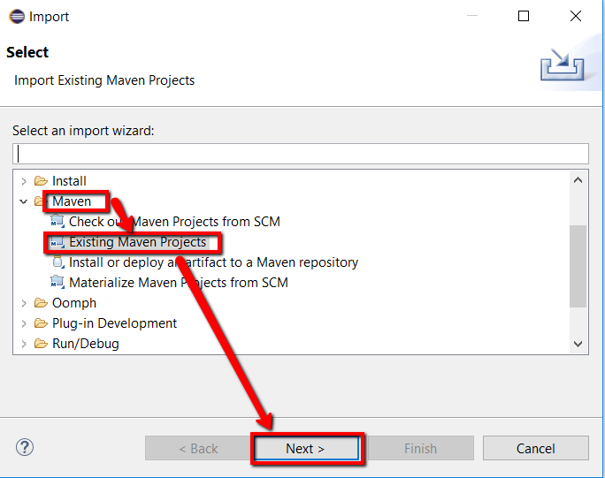

1. Browse the pom.xml/git project located in Local to your IDE.

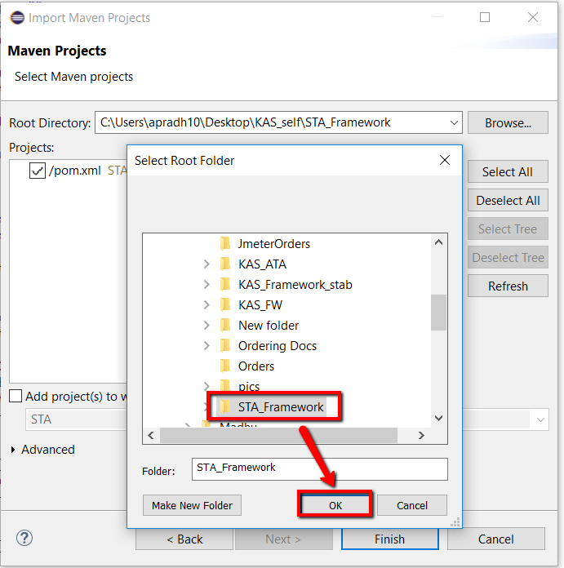

1. Now you should able to see the pom.xml which to be imported to IDE.

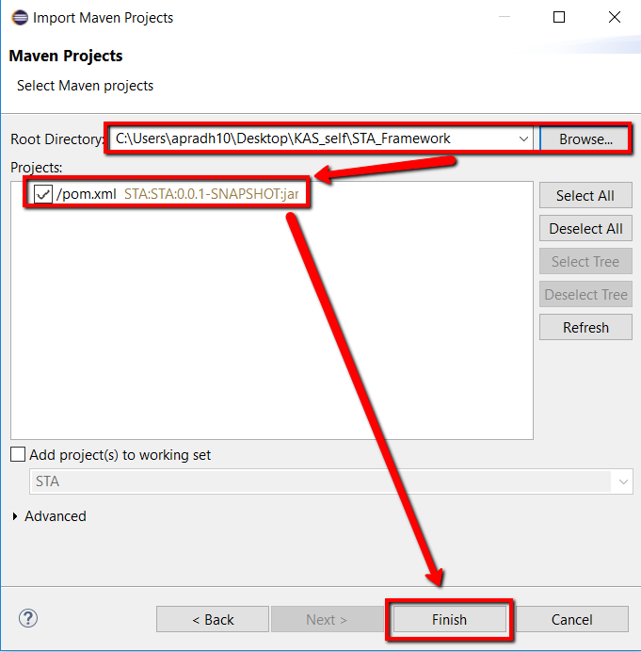

1. Now you should able to see the project structure in your IDE as below

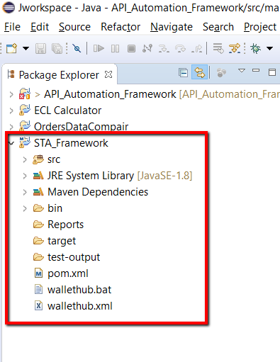

1. Update the project to download all dependanciy jar files in your local repo -> M2

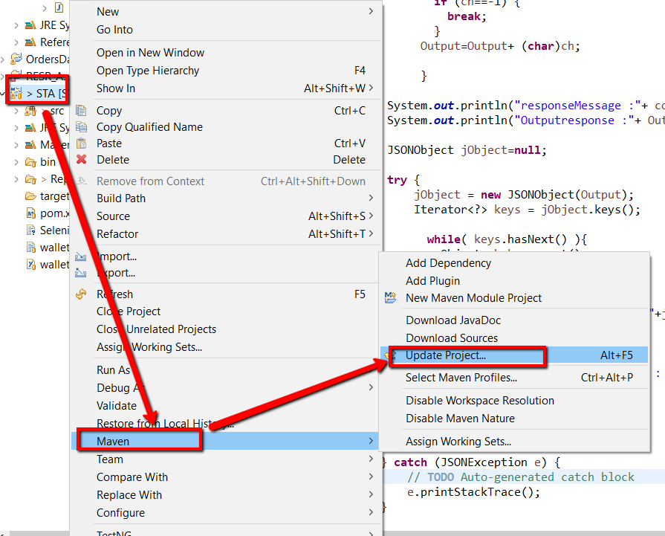

1. Expand the project as shown below and you should be able to see the config file.

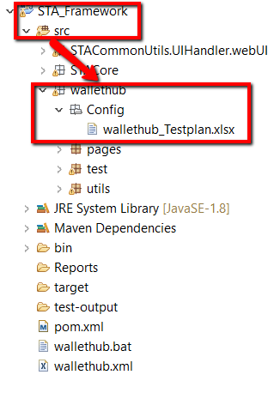

1. Open the testplan , navigate to testplan sheet and make the flag ON for the respective suite (Facebook/wallethub).

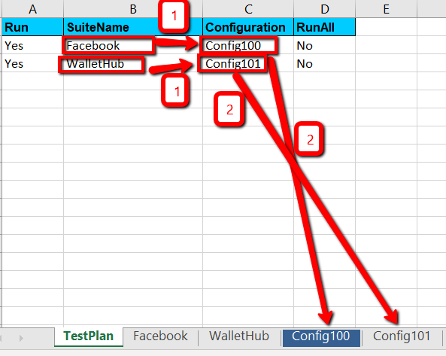

1. Goto the respective Configuration sheet mentioned against the test plan and provide the user data/credentials required to execute the suite.

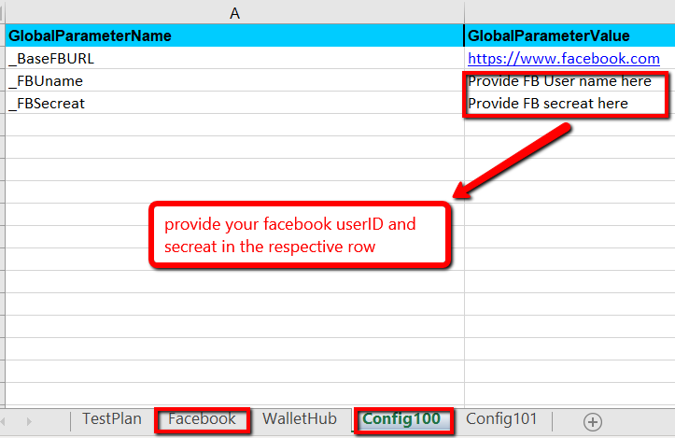

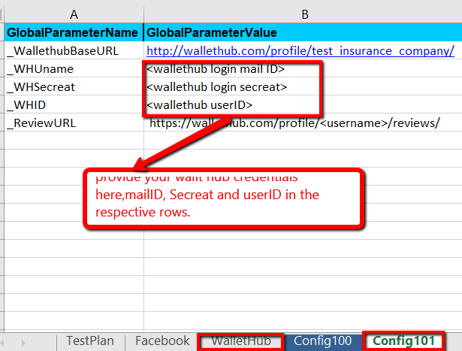

1. Navigate to the facebook sheet to execute the facebook suite related test cases,set the browser either firefox/chrome or ie as the requirement need
2. For the test case **Facebook_StatusPost_Test** in the parameter session provide the message you wanted to post in the facebook post.

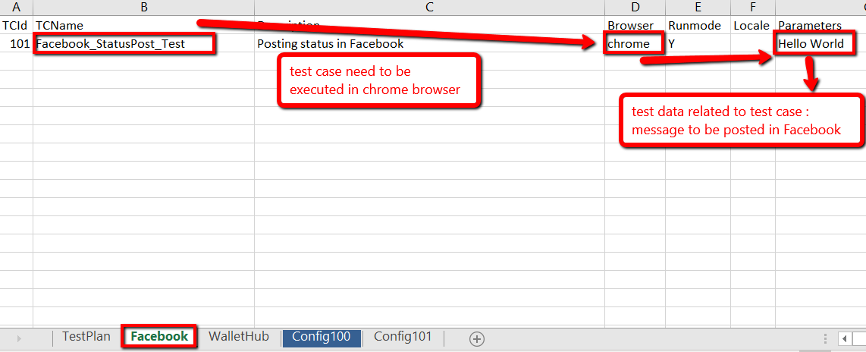

1. Make the respective changes in the wallethub sheet to execute respective test cases.

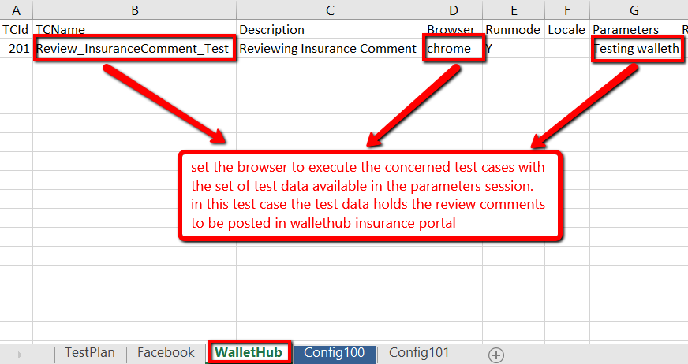

1. Start Execution the testing Suite :

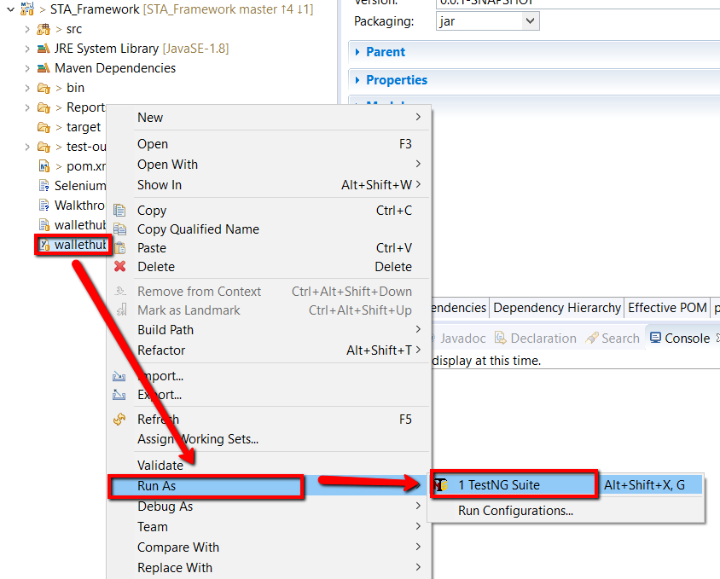

1. Overview of framework placeholder

